Lotus Europa S1B

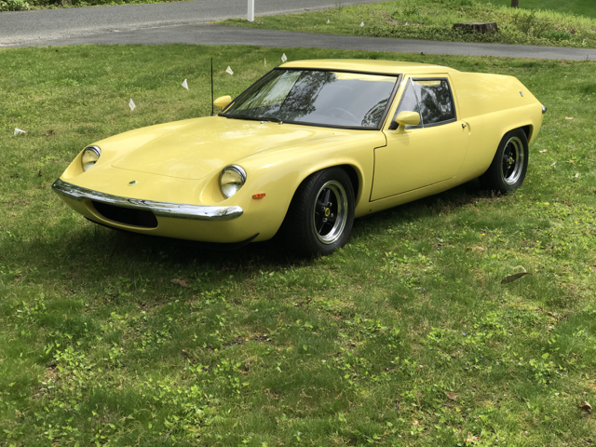

This is a well preserved and rare early Lotus Europa S1B (Type 46), number 46-0568, with original engine (number 697-04/0657), purchased by the seller on January 8th 1969, from the original owner, an artist, who had completed just 400 miles in the year he had it. His reason for sale was that the luggage compartment was too small…!

The Lotus certificate of provenance states that this vehicle left the factory on 29th February 1968. It was the fourth Europa sold at Lotus East. 1,470cc, four liter, mid-engine, two door GT coupe.

I have been asked to sell this Europa as well as the Lotus Esprit S4 Turbo 2.2 1994, which shares the other side of the garage, as the owner is no longer able to drive. The owner has original purchase documents, certificate of title, receipts from 1996 to the present, the workshop manual and supplement

In the owners’ own words, “I have owned and raced Lotuses since the early 1960s (after training at Lime Rock) and was my own race mechanic. The racecars have included a Lotus 7, a Lotus 23B and a Lotus Europa (type 47). More recently I have owned a Lotus Esprit S1 1977 (red with tartan interior) which I restored seven years ago and more recently a Lotus Esprit S4 2.2 liter Turbo which is also up for sale.”

“This is the early model Europa so it still has the high side wings and no running lights on the front nose, as well as flat front fenders.”

“The car is very much as original as possible but has had a few upgrades. One of the first I did after a few years of ownership was to replace the door handles with the S2 MGB version. Then I put in electronic ignition and a high power “ignitor” coil, adjustable Spack shocks all round and a one third enlarged radiator and fan. Somewhere along the line new carpets were added and the battery moved to the back left wing. The headlights also have been upgraded and the pop-out windows replaced with Lexan. The adjustable wing mirrors are from a Mustang, not sure which one.”

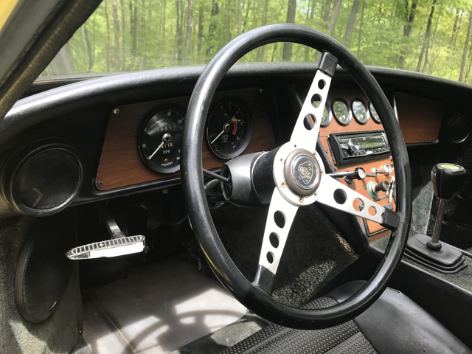

“This Europa has never been raced, merely being maintained for daily use and has 44,107 miles on it. The car has never been in an accident and was repainted in it’s original yellow once years ago. It is my pride and joy, and is an absolute delight to drive and handles much like my race cars.”

The radio was bought recently but has not been installed. The air-horn push is now cleverly disguised as a cigar lighter.

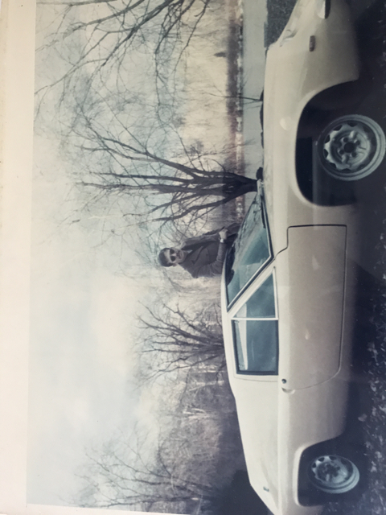

Owner‘s brother in shades leaning on the Europa wishing he’d bought it… Owner racing his 23B and 7 as well as the type 47 Europa…. The 1991 Lotus Owners gathering at Waterbury, CT, show this Europa holding a bunch of balloons surrounded by a bunch of S2’s…

Condition. I have tried to show much of the fiberglass issues in the images most of which are pretty minor, the worst being under the nose. The passenger glove box is missing. Front chrome bumper is new and the back is original. Wheels were replaced years ago and have P175x70xR13 Toyo Spectrum tires. Oh, yeah, the spare tire is original..!

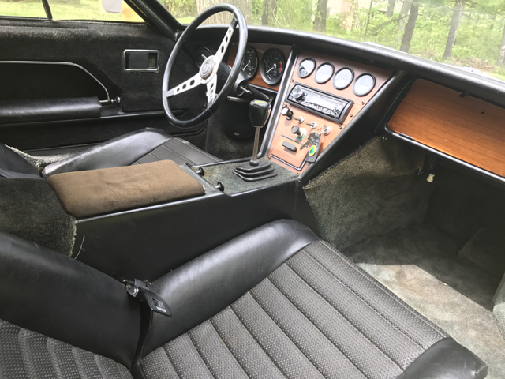

Mechanically. There has been a great deal of sorting out and cleaning up over the last year with invoices to show the work done on the brakes, new shoes all round, all lights tested and working, alternator rebuilt, new plugs and wire set, timing checked, compression test, rear suspension bushes replaced. The car is currently slow to start cold (but always does start), restarts the rest of the day no problem and runs well.

As I’m sure many of you will agree, the S1 has the cleanest lines of the Europas with no turn signal warts on the front of the car, no door handles, a single wiper, simplified dash and lower stance than later models. The purest and the lightest of the Europas weighing in at just 1350 Lbs.

